The Traffic Light
You all know how a set of traffic lights works. This lab challenges you to make your own traffic lights for a simple intersection. You will have two sets of red, yellow, and green lights and need to figure out the patterns and timings to make them operate as traffic lights.
NOTE! This is the first week of two that will use the traffic lights. I suggest that you build your circuit at the top of your breadboard and just leave it there for the next week. There is plenty of space below for the labs in between.

Lights!
I have provided you with two sets of red, yellow, and green LEDs. An LED is a diode made from different materials than the usual silicon rectifier diode so it has a different turn-on voltage, typically about 1.8V instead of the usual 0.6V (this reflects the extra energy needed to generate light). The LEDs that we use need about 10mA of current to light up brightly. That is a lot more than our little computers can supply, so we need some way to control a large current for the LED with the tiny current from your computer. The ULN2803 is a special chip to drive moderate current loads such as LEDs and small motors. The figure on the right shows how to use one of the drivers in a ULN2803 to control an LED.
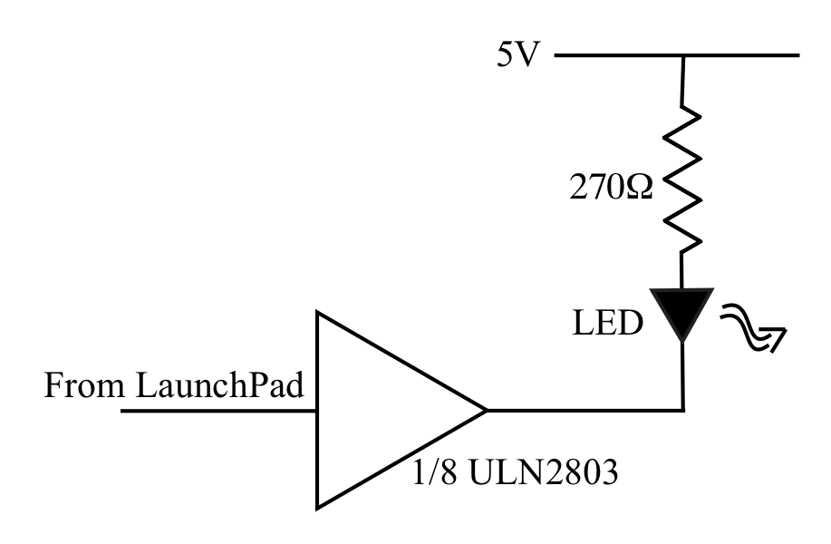

More Lights
When you get to the traffic light, you will have six LEDs to drive so you will need six such circuits. In the IC drawer of your blue box you should find a ULN2803 chip. This contains eight identical circuits, each designed to switch current to a load such an LED. The figure on the right shows how the drivers are arranged inside the chip.
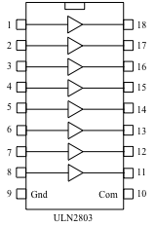
NOTE: You need to ground pin 9 but there is, unusually, no pin to connect to power. Since the load (the LED) is connected to power on the side away from the chip, the chip does not need its own power connection.
Pin 10 is normally unconnected but can be used to test that your LEDs are in the right way round. If you ground pin 10 then all your LEDs should turn on.
Select one of your LEDs and wire it to an output the ULN2803 and wire the ULN’s corresponding input one of the port pins on your Feather board.
Test your system with a program that blinks the LED at some nicely visible rate. Append the commented program to the lab.
# Author: Ben Kallus
# Blinks an LED on D6.

import board
import digitalio
import time

led = digitalio.DigitalInOut(board.D6)
led.direction = digitalio.Direction.OUTPUT

while True:
led.value = True
time.sleep(.3)
led.value = False
time.sleep(.3)

A more complex task
You have one LED blinking. Now wire up a second LED, preferably a different color, to a second Feather pin in the same sort of way. NOTE: Each LED needs its own resistor or some very odd things will happen.
Task 1: Your first challenge is to make the two LEDs blink. To make things interesting I would like to see you blink a pattern something like
LED1 ------ ------ ------ ------ ------
LED2 ------ ------ ------ ------
so that we see a pattern of overlapping blinks. Append your commented program to the lab.
# Author: Ben Kallus
# Blinks LEDs on D5 and D6 in an overlapping pattern.

import board
import digitalio
import time

led1 = digitalio.DigitalInOut(board.D6)
led1.direction = digitalio.Direction.OUTPUT
led2 = digitalio.DigitalInOut(board.D5)
led2.direction = digitalio.Direction.OUTPUT

while True:
led1.value = True
time.sleep(.5)
led2.value = True
time.sleep(.5)
led1.value = False
time.sleep(.5)
led2.value = False
time.sleep(.5)

Your first traffic light
Using your ULN2803, wire up six LEDs in groups of three arranged to look like traffic lights. Remember that you need a separate 270Ω resistor for each LED. Connect these to six of the port bits of your computer. You can choose how to allot them.

Naming your LEDs
Now you are ready to write your traffic light program. It is only a little more complicated than the previous program. There is one trick to make your life a little easier. At the moment you have to remember which LED is connected to which port pin. It will be a lot easier if you name them in the program by their function so that you could have eg. LEDs called redNS or greenEW that you set up with something like
redNS = digitalio.DigitalInOut(board.D8)
assuming that the north-south red light is connected to pin D8.
Then when you want to turn on the north-south red LED you can say
RedNS.value = 1
and your intent will be obvious.
Task 2: Write your traffic light program and demonstrate it to me. Append the commented program to the lab and save it on your hard drive because you are going to need it again.
# Author: Ben Kallus
# Blinks LEDs in a traffic light pattern.

import board
import digitalio
from time import sleep

DELAY = 1

r_ns = digitalio.DigitalInOut(board.D11)
y_ns = digitalio.DigitalInOut(board.D10)
g_ns = digitalio.DigitalInOut(board.D9)
r_ew = digitalio.DigitalInOut(board.D6)
y_ew = digitalio.DigitalInOut(board.D5)
g_ew = digitalio.DigitalInOut(board.SCL)

r_ns.direction = digitalio.Direction.OUTPUT
y_ns.direction = digitalio.Direction.OUTPUT
g_ns.direction = digitalio.Direction.OUTPUT
r_ew.direction = digitalio.Direction.OUTPUT
y_ew.direction = digitalio.Direction.OUTPUT
g_ew.direction = digitalio.Direction.OUTPUT

while True:
# G R
r_ns.value = False
g_ns.value = True
r_ew.value = True
sleep(DELAY)

# Y R
g_ns.value = False
y_ns.value = True
sleep(DELAY)

# R R
y_ns.value = False
r_ns.value = True
sleep(DELAY)

# R G
r_ew.value = False
g_ew.value = True
sleep(DELAY)

# R Y
g_ew.value = False
y_ew.value = True
sleep(DELAY)

# R R
y_ew.value = False
r_ew.value = True
sleep(DELAY)

If time permits: Try to add a pedestrian call button that will extend the next red-red period to allow time for pedestrians to cross the street.
Time did not permit :(

Remember to leave your circuit set up.

